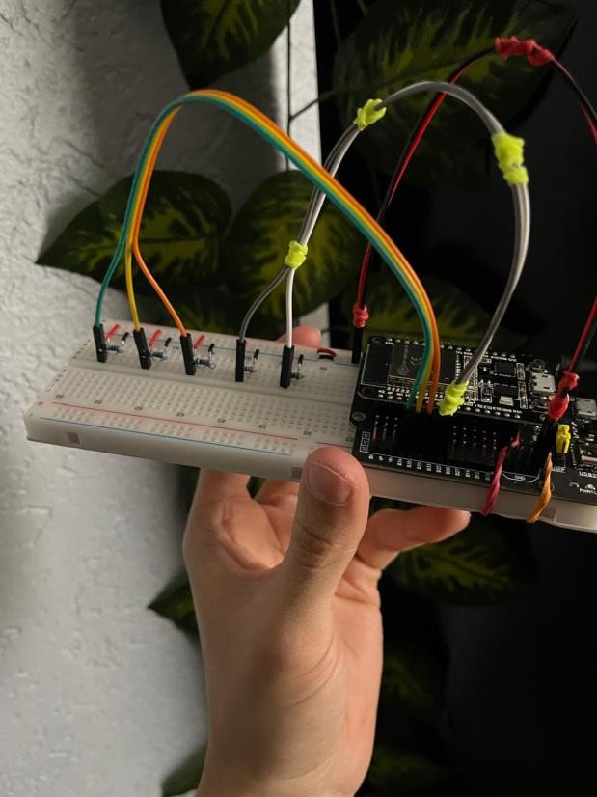

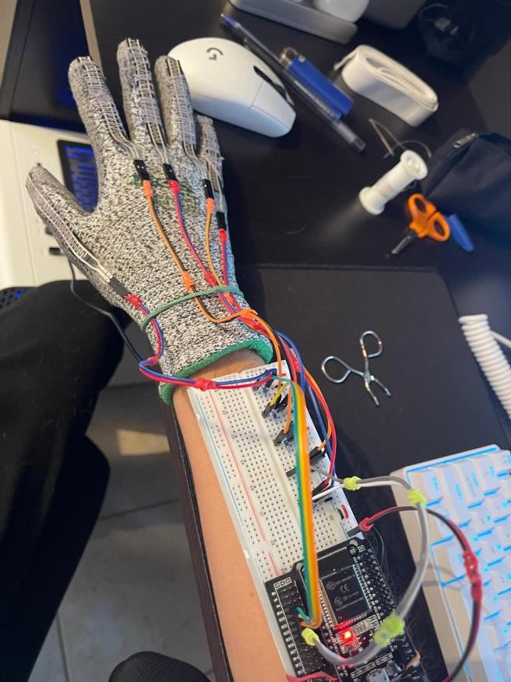

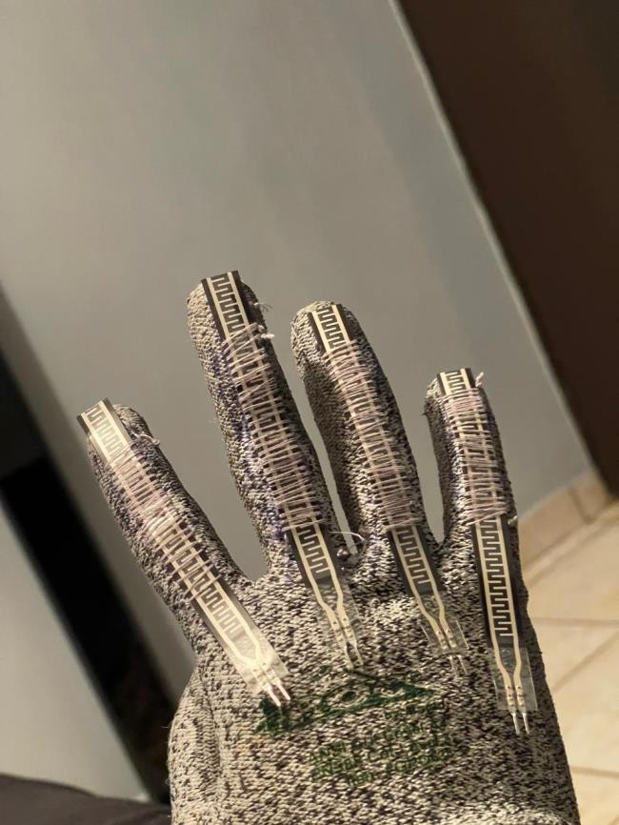

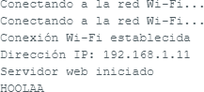

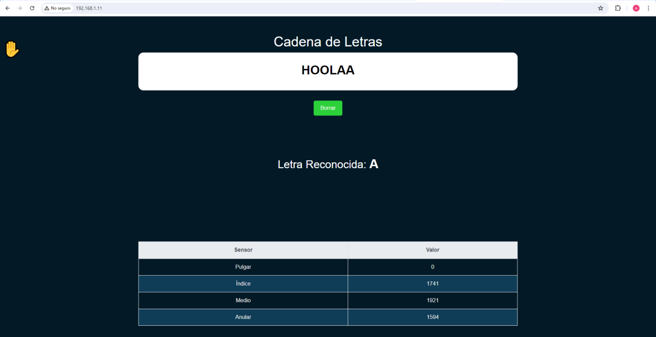

#include <WiFi.h> #include <WebServer.h>

// Define los pines que utilizamos para cada sensor de flexión

const int pulgarPin = 34; // Pin del sensor de flexión del pulgar const int indicePin = 35; // Pin del sensor de flexión del índice const int medioPin = 32; // Pin del sensor de flexión del dedo medio const int anularPin = 33; // Pin del sensor de flexión del anular const int meniquePin = 25; // Pin del sensor de flexión del meñique

WebServer server(80);

String cadena = ""; char letra = ' ';

void handleRoot() {

int pulgarVal = analogRead(pulgarPin); int indiceVal = analogRead(indicePin); int medioVal = analogRead(medioPin); int anularVal = analogRead(anularPin);

letra = reconocerLetra(pulgarVal, indiceVal, medioVal, anularVal); if (letra != ' ') {

cadena += letra;

}

String html = "<!DOCTYPE html>"; html += "<html lang=\"es\">"; html += "<head>";

html += "<meta charset=\"UTF-8\">";

html += "<meta name=\"viewport\" content=\"width=device-width, initial- scale=1.0\">";

html += "<title>Sensores de Flexión</title>"; html += "<link rel=\"stylesheet\"

href=\"https://stackpath.bootstrapcdn.com/bootstrap/4.5.2/css/bootstrap.min. css\">";

html += "<style>";

html += "body { background-color: #031926; color: #ffffff; font-family: Arial, sans-serif; position: relative; margin-top: 0; }"; // Ajuste para eliminar el margen superior

html += ".container { margin-top: 50px; }";

html += ".cadena { background-color: #ffffff; padding: 30px; margin- bottom: 30px; color: #000000; border-radius: 15px; }";

html += ".letra { font-size: 36px; font-weight: bold; }";

html += ".btn-borrar { background-color: #2CD039; color: #ffffff; border: none; padding: 10px 20px; border-radius: 5px; cursor: pointer; transition: background-color 0.3s ease; }";

html += ".btn-borrar:hover { background-color: #24a82d; }";

html += "table { width: 100%; border-collapse: collapse; margin-top: 30px;

}";

html += "th, td { border: 1px solid #ffffff; padding: 10px; text-align: center; }";

html += "th { background-color: #1b4b72; }";

html += "tr:nth-child(even) { background-color: #0f3c56; }";

html += ".hand-emoji { font-size: 48px; position: absolute; top: 0; left: 0; margin: 10px; }";

html += "</style>"; html += "</head>"; html += "<body>";

html += "<div class=\"container\">";

html += "<span class=\"hand-emoji\">✋</span>";

html += "<h1 class=\"text-center\">Cadena de Letras</h1>"; html += "<div class=\"cadena\">";

html += "<h2 class=\"text-center letra\">" + cadena + "</h2>"; html += "</div>";

html += "<div class=\"text-center\">"; html += "<button class=\"btn btn-borrar\"

onclick=\"borrarCadena()\">Borrar</button>"; html += "</div>";

html += "<br>"; html += "<br>"; html += "<br>"; html += "<br>"; html += "<br>";

html += "<h2 class=\"text-center\">Letra Reconocida: <span class=\"letra\">" + String(letra) + "</span></h2>";

html += "<br>"; html += "<br>"; html += "<br>"; html += "<br>"; html += "<br>"; html += "<br>"; html += "<br>";

html += "<table class=\"table\">";

html += "<thead class=\"thead-light\">";

html += "<tr><th>Sensor</th><th>Valor</th></tr>"; html += "</thead>";

html += "<tbody>";

html += "<tr><td style=\"color: #f0f0f0;\">Pulgar</td><td style=\"color: #f0f0f0;\">" + String(pulgarVal) + "</td></tr>";

html += "<tr><td style=\"color: #f0f0f0;\">Índice</td><td style=\"color: #f0f0f0;\">" + String(indiceVal) + "</td></tr>";

html += "<tr><td style=\"color: #f0f0f0;\">Medio</td><td style=\"color: #f0f0f0;\">" + String(medioVal) + "</td></tr>";

html += "<tr><td style=\"color: #f0f0f0;\">Anular</td><td style=\"color: #f0f0f0;\">" + String(anularVal) + "</td></tr>";

html += "</tbody>"; html += "</tbody>"; html += "</table>"; html += "</div>"; html += "<script>";

html += "function borrarCadena() {"; html += " fetch('/borrar')";

html += " .then(response => {";

html += " console.log(response);"; html += " window.location.reload();"; html += " });";

html += "}";

html += "</script>"; html += "</body>"; html += "</html>";

server.send(200, "text/html", html);

}

void handleBorrar() {

// cadena de borrar cadena = "";

server.send(200, "text/plain", "Cadena de letras borrada.");

}

void setup() { Serial.begin(9600);

// Inicializa los pines de los sensore pinMode(pulgarPin, INPUT); pinMode(indicePin, INPUT); pinMode(medioPin, INPUT); pinMode(anularPin, INPUT); pinMode(meniquePin, INPUT);

// Se conecta a la red Wi-Fi WiFi.begin("Mega_2.4G_7C86", "RSSYAPNT"); while (WiFi.status() != WL_CONNECTED) {

delay(1000);

Serial.println("Conectando a la red Wi-Fi...");

}

Serial.println("Conexión Wi-Fi establecida");

// Imprime la dirección IP asignada al dispositivo Serial.print("Dirección IP: "); Serial.println(WiFi.localIP());

// Registra los manejadores de ruta server.on("/", handleRoot); server.on("/borrar", handleBorrar);

server.begin();

Serial.println("Servidor web iniciado");

}

void loop() { server.handleClient();

}

char reconocerLetra(int pulgar, int indice, int medio, int anular) {

// A

if (pulgar <= 100 && indice >= 1000 && medio >= 1000 && anular >= 1000) { Serial.print("A");

delay(10); return 'A';

}

// H

if (pulgar >= 1000 && indice < 500 && medio < 700 && anular >= 1000 ) { Serial.print("H");

delay(10); return 'H';

}

// L

if (pulgar < 200 && indice < 200 && medio >= 1100 && anular >= 1100 ) { Serial.print("L");

delay(10); return 'L';

}

// O

if (pulgar >= 1100 && indice >= 1100 && medio >= 1100 && anular >= 1100 )

{

Serial.print("O"); delay(10);

return 'O';

}

// B

if (pulgar >= 1100 && indice < 700 && medio < 700 && anular < 700 ) { Serial.print("B");

delay(10); return 'B';

}

// D

if (pulgar >= 1100 && indice < 700 && medio >= 1100 && anular >= 1100) { Serial.print("D");

delay(10); return 'D';

}

// F

if (pulgar >= 1100 && indice >= 1100 && medio < 700 && anular < 700) { Serial.print("F");

delay(10); return 'F';

}

return ' ';

}